**Q1. What is software? & What is software engineering?**

ANS: Software is a set of computer programs and associated documentation and data.

Software engineering is the process of developing, testing and deploying computer applications to solve real-world problems by adhering to a set of engineering principles and best practices.

**Q2. Explain types of software?**

ANS: main two types of software: 1. APPLICATION SOFTWARE

2. SYSTEM SOFTWARE

1. An application is software that fulfills a specific need or performs tasks.

2. System software is designed to run a computer's hardware and provides a platform for applications to run on top of. /EX:- opreting systems.. linux/window…

&

3. **Driver software:**Also known as device drivers, this software is often considered a type of system software. /EX:- usb driver…..

4. **Middleware.**The term *middleware* describes software that mediates between application and system software or between two different kinds of application software. /EX:- mx player, vlc ….

5. **Programming software.** Computer programmers use programming software to write code. /EX:- turbo c, visual studio, devc++….

**Q3.** **What is SDLC? Explain each phase of SDLC?**

ANS: SDLC :-software development life cycle

_An SDLC (software development life cycle) is a big-picture breakdown of all the steps involved in software creation (planning, coding, testing, deploying, etc.

The character and the exact number of phases in an SDLC vary between businesses and projects. The most common models are variations on the following steps:

* Requirement analysis.
* In-depth planning.
* Product design.
* Coding.
* Testing.
* Deployment.
* Post-production maintenance.

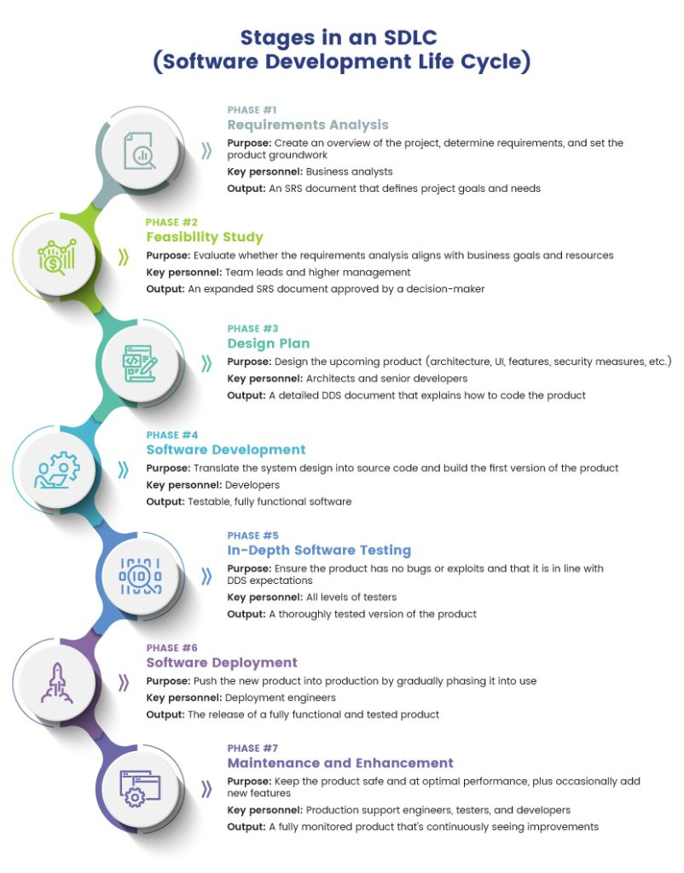

**Q4.What is DFD? Create a DFD diagram on Flipkart**

ANS:- A data flow diagram (DFD) **maps out the flow of information for any process or system**.